**Food Ordering System**

This is a project of food ordering system consists of a JAVA and MySQL code that has been produce the simple output like ordering a food and storing it for a future purpose and can be further process the data.

* + **The tables can be created in MySQL Code**
* Customer and their role
* Restaurant
* Food items in whole
* Food menu in particular restaurant
* Add on like starters, side dishes...
* Order(Link with Customer and Restaurant)
* Order detail(Multiple Order)
* Rating or review
* Discount

By

JAGADEESH.M

VSB ENGINEERING COLLEGE

KARUR.

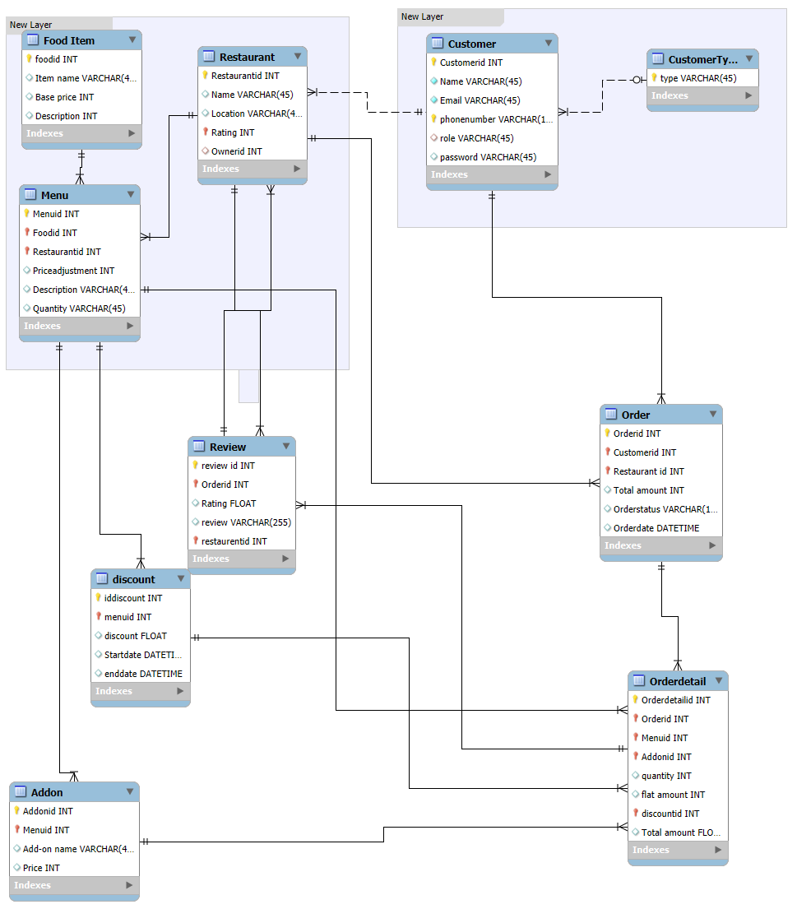

Fig. ERD Diagram

This diagram shows that the flow of execution of my project. With this you can get an idea of about my project.

I have attached a Source code of MySQL code with this you can run on this and in java src file you can change the PASS and USERNAME accordingly so you can run the code.